One Flew Over The Cuckoo’s Nest (1975)
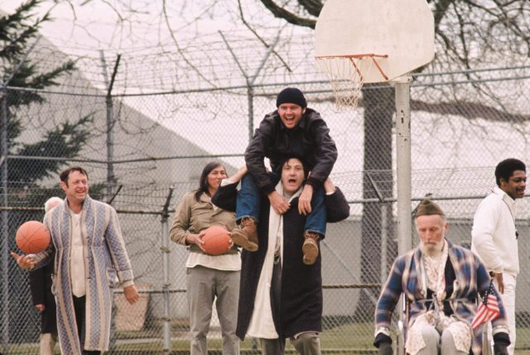One Flew Over the Cuckoo's Nest. Digital image. IMDb. N.p., 10 Aug. 2010. Web. 17 Mar. 2016. <http://www.imdb.com/media/rm1940750592/tt0073486?ref_=ttmd_md_nxt>.
Cast:
- Jack Nicholson as Randle McMurphy
- Louise Fletcher as Nurse Ratched
- Will Sampson as Chief Bromden
- Danny DeVito as Martini
- William Redfield as Dale Harding
- Brad Douriff as Billy Bibbit
- Sydney Lassick as Charley Cheswick
- Josip Elic as Bancini
- Christopher Llyod as Taber

Director: Milos Forman

Drama
Rated R for some nudity, sexual content, violence, profanity, & alcohol/drugs/smoking
133 minutes

Emily Hamner
March 15 2016

When Ken Kesey-- author of One Flew Over the Cuckoo’s Nest -- decided to pass up the opportunity of turning his novel into a film version, he made an asinine mistake. So maybe the movie wasn’t equivalent to the original book, the adaptation into a film complimented the already distinguished piece of literature; also allows the viewers to identify the inside of the psych ward. Milos Forman seized the plot of the story while also adding in his own exquisite insight that transformed One Flew Over the Cuckoo’s Nest into a five time Academy Award winner.

The film was great because of its acting choices. Jack Nicholson helped Forman tremendously in transforming the acclaimed character of Randle McMurphy.

Mr. McMurphy was admitted into the ward at the beginning of the fim, and from the second he walked in, he was causing havoc in the ward, upsetting Nurse Ratched the ward’s “Big Nurse” (Kesey, 4), played by Louise Fletcher. “Mac”, as the patient's called him, not only caused the Nurse to collapse, but it also led to the uprise in rebellious acts and resolute lines. One action leading the Nurse into hatred toward McMurphy was during a group meeting; Nurse Ratched (within the film) was firing questions at McMurphy about his condition, and his response was “Is that crazy enough for ya? Want me to take a shit on the floor?”

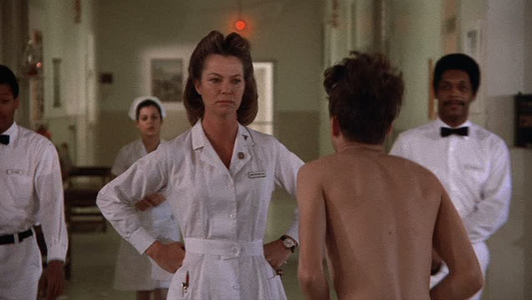

Although there were many ways McMurphy got into the Nurse’s head, not all were portrayed in the film (such as when he suggest that playing card in the tub room and got Ratched’s staff turned against her) his rebellion and power over the Nurse shined through his foul mouth in the film, but as well as in Kesey’s novel.

Nicholson enhanced his personality through the characterization of McMurphy, and created an astonishing performance, by augmenting gusto and character.

Milos Forman could have had everything else go wrong within his film, but since he chose to cast Jack Nicholson as Randle Patrick McMurphy, well obviously, since he won an Oscar, it was a brilliant choice.

Although casting Nicholson was an award winning decision, Forman also made his film adaptation spectacular through the camera angles, it was sort of the icing on the cake. The perfect example of this happened throughout the film, as the Nurse seemed to have total control over the ward before McMurphy showed up in the book and the movie, but once he arrived, havoc broke loose, the camera angle would shift facing down on her-- showing the power struggle between her and McMurphy-- with him having the power over her.

Milos Forman should go on forever blowing his own horn for the justice he did to One Flew Over the Cuckoo’s Nest through his film adaptation. It goes without saying, Jack Nicholson was the best for the job, and it is apparent that Milos paid attention to even the smallest of details, such as what angle the camera should be at in order to show the constant power struggle going on between him and the Nurse. Also, mix in his brilliance when it came to the casting choices of the smaller roles like Cheswick, played by Sydney Lassick, and Martini, played by Danny, DeVito, along with his music choices, dialogue choices, and even the opening and closing scenes, the film's success was absolutely inevitable.

As Nicholson or better yet-- Randle McMurphy would say, Milos Forman was “a goddamn marvel of modern science.”

Overall Rating: 8.5/10
The film is very moving and a truly has a beautiful cinematic experience. Every single actor gave a stellar performance, every single character was perfectly written to capture the “crazy” through every line, and every single frame is absolutely perfect.

SCORE: 30/40pts.

